**KOCKA A KVÁDER**

1. Zakresli nárys, pôdorys a pravý bokorys zobrazeného telesa:

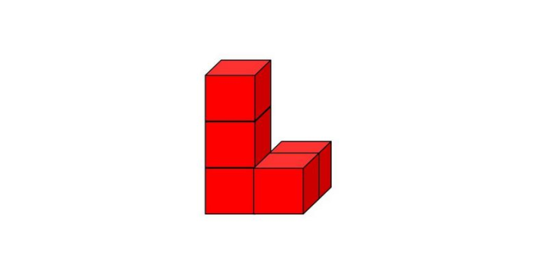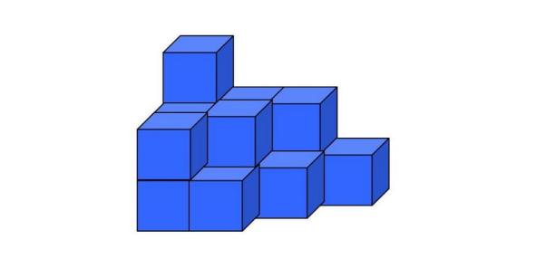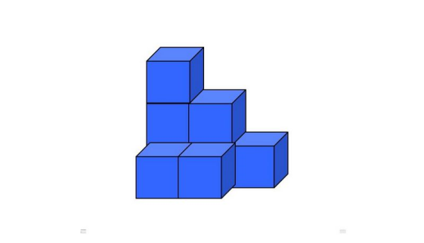

|  |  |  |  |  |  |  |  |  |  |  |  |  |  |  |  |  |  |
| --- | --- | --- | --- | --- | --- | --- | --- | --- | --- | --- | --- | --- | --- | --- | --- | --- | --- |
| pôdorys |  |  |  |  |  |  |  |  |  |  |  |  |  |  |  |  |  |
|  |  |  |  |  |  |  |  |  |  |  |  |  |  |  |  |  |  |
|  |  |  |  |  |  |  |  |  |  |  |  |  |  |  |  |  |  |
|  |  |  |  |  |  |  |  |  |  |  |  |  |  |  |  |  |  |
|  |  |  |  |  |  |  |  |  |  |  |  |  |  |  |  |  |  |
| nárys |  |  |  |  |  |  |  |  |  |  |  |  |  |  |  |  |  |
|  |  |  |  |  |  |  |  |  |  |  |  |  |  |  |  |  |  |
|  |  |  |  |  |  |  |  |  |  |  |  |  |  |  |  |  |  |
|  |  |  |  |  |  |  |  |  |  |  |  |  |  |  |  |  |  |
|  |  |  |  |  |  |  |  |  |  |  |  |  |  |  |  |  |  |
| bokorys |  |  |  |  |  |  |  |  |  |  |  |  |  |  |  |  |  |
|  |  |  |  |  |  |  |  |  |  |  |  |  |  |  |  |  |  |
|  |  |  |  |  |  |  |  |  |  |  |  |  |  |  |  |  |  |
|  |  |  |  |  |  |  |  |  |  |  |  |  |  |  |  |  |  |
|  |  |  |  |  |  |  |  |  |  |  |  |  |  |  |  |  |  |

2. Narysuj kocku a = 3 cm vo voľnom rovnobežnom premietaní.

3. Narysuj kváder a =5cm, b = 4 cm, c = 3 cm vo voľnom rovnobežnom premietaní.

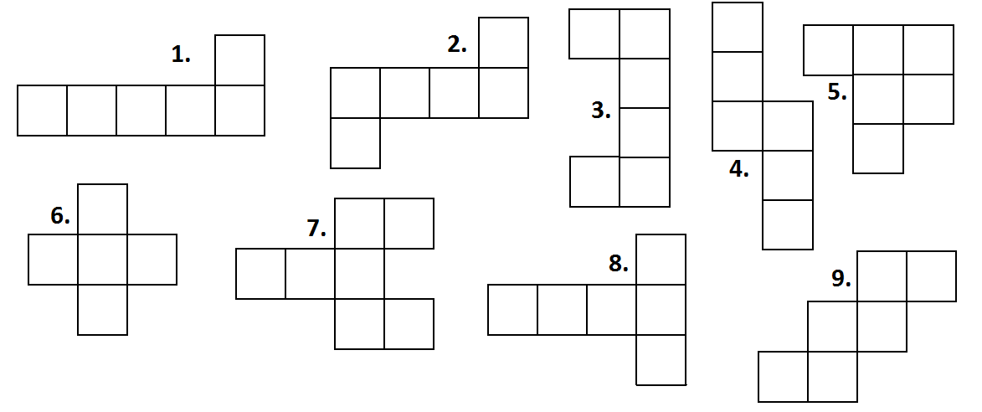 4. Na ktorých obrázkoch je sieť kocky a na ktorých nie je?

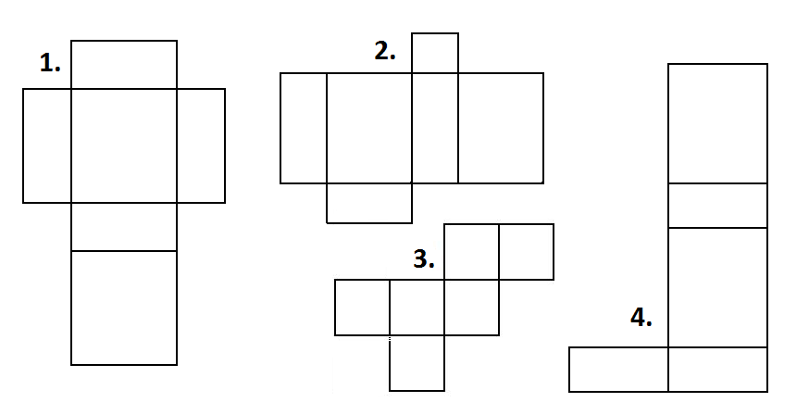5. Na ktorých obrázkoch je sieť kvádra a na ktorých nie je?

**JEDNOTKY OBJEMU**

1. Doplň tabuľku:

|  |  |  |  |  |  |
| --- | --- | --- | --- | --- | --- |
| m3 | dm3 | cm3 | mm3 | l | hl |
| 5 |  |  |  |  |  |
|  | 0,25 |  |  |  |  |
|  |  | 1200 |  |  |  |
|  |  |  | 5550000 |  |  |
|  | 72000 |  |  |  |  |

2. Premeňte na jednotku uvedenú v zátvorke

6 dm (cm) 99 cm (mm)

1,85 m (mm) 0,3 km (m)

0, 07 dm (mm) 6300 mm (cm)

700 dm (m) 42,3 cm (dm)

5,3 hl (l) 0, 89 l (ml)

37 dm (cm) 123 cm (mm)

7120 dm (m) 5647 cm (dm)

47,1 l (dl) 5,6 hl (l)

51 cm3 (dm3) 0,26 cm3 (mm3)

58 cm3 (m3) 300 mm3 (cm3)

3. Porovnaj pomocou znakov < , > a = :

1. 968 cl 9,68 l
2. 563 dm3 56,3 l
3. 859 ml 0,0859 dl
4. 9hl 65dl 90,65 dm3
5. 7042 cm3 7042 ml

4. Vypočítaj, výsledok uveď v ľubovoľnej jednotke objemu :

1. 954 ml + 32,8 cl =
2. 93,92 m3 + 54, 8 dm3 =
3. 6,52 hl – 51,75 l =
4. 860,7 mm3 – 0,3798 cm3 =
5. 903,76 dm3 + 64,659 cm3 – 7 479 300 mm3 =